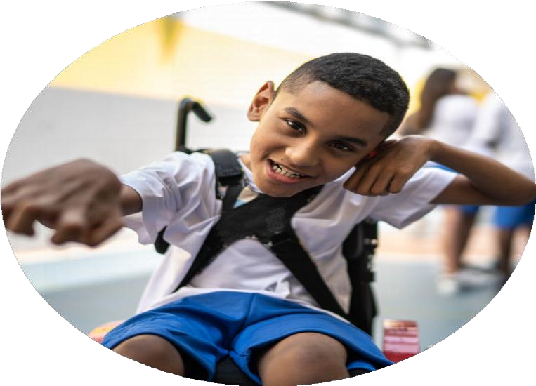

**PE**

**Funding**

**Evaluation**

Images

courtesy

of

Youth

Sport

Trust

**Swimming Data**

**Meeting National Curriculum requirements for swimming and water safety**

Priority is given to ensuring children can perform safe self-rescue even if they do not fully meet the first two requirements of the National Curriculum programme of study

|  |  |  |
| --- | --- | --- |
| What percentage of your current Year 6 cohort can swim competently, confidently and proficiently over a distance of at least 25 metres?    What percentage of your current Year 6 cohort can use a range of strokes effectively [for example, front crawl, backstroke, and breaststroke]? | 87%      82% | This cohort benefit from additional swimming sessions as part the PE curriculum in summer term where we focus on non swimmers.    Data obtained from parent survey/Swimphony |

|  |  |  |
| --- | --- | --- |
| What percentage of your current Year 6 cohort are able to perform safe self-rescue in different water-based situations? | 82% |  |
| If your schools swimming data is below national expectation, you can choose to use the Primary PE and sport premium to provide additional top-up sessions for those pupils that did not meet National Curriculum requirements after the completion of core lessons. Have you done this? | Yes | Children received 2 weeks of blocked tuition in  Year 4 and 6 where non swimmers are targeted. |
| Have you provided CPD to improve the knowledge and confidence of staff to be able to teach swimming and water safety? | No | Children attend local swimming baths (Thornaby- Tees Active) and are taught by swimming instructors |

**Review of last year 2023/24**

We recommend that you start by reflecting on the impact of current provision and reviewing your previous spend

|  |  |  |  |
| --- | --- | --- | --- |
| **What went well?** | **How do you know?** | **What didn’t go well?** | **How do you know?** |
| PE specialist to enrich the curriculum and support teaching staff throughout the school. A focus on upskilling KS2 staff for 24-25  The installation and continued use of the orienteering  course provided by Enrich Education.      Trust Cup- funded by Prince Regent Street Trust  Competing in out of school competitions as part of SSSP | * Increase engagement and physical activity from all students taking their learning from outside the classroom and being physically active.      * Increased staff confidence. * Attainment levels have risen and assessment .      * Improved curriculum delivery. * Upskilling teaching staff to deliver high quality PE. * Increased staff confidence * All classes from KS1 and KS2 accessing orienteering course during cross curricular lessons. Lessons more active * Children developed teamwork and social skills interacting with children from trust schools and building new relationships. * Children’s confidence increased as they felt part of a team and allowed the opportunity to represent the school at a competitive level. | The development of the lunchtime activity programme led by mid-day supervisors. | The lack of activities being led by mid-day supervisors during  lunchtimes.    Equipment and resources not being used during lunchtimes. |

**Intended**

**actions**

**for**

**2024**

**/**

**25**

Grant Allocation £17,720 Allocated Spending £18,982.35

|  |  |  |
| --- | --- | --- |
| **What are your plans for 2024/25?** |  | **How are you going to action and achieve these plans?** |
| **Intent** |  | **Implementation** |
| 1) To increase the engagement of all pupils in regular physical activity – the Chief Medical Officer guidelines recommend that all children and young people aged 5 to 18 engage in at least 60 minutes of physical activity per day, of which 30 minutes should be in school. (Active 60) campaign. |  | Purchase playground equipment   * The continuation and investment into our Sports Leaders – sport leader training in September * Employ sports coaches to facilitate playground games as well as lead lessons. * Provide age-appropriate resources to allow younger children to develop gross motor skills through active playtimes and within the curriculum. To enhance attainment in PE within EY, SEND equipment/OT * Promote the engagement of all pupils in regular physical activity – kick-starting healthy active lifestyles through the provision of extra-curricular clubs. * Provide opportunities for children to engage in non-curriculum activities/sports eg Rock Climbing, Sports Festivals and scavenger hunts, orienteering, OAA activities/residentials * The introduction of Orienteering to support cross curricular opportunities. |
| **Funding Allocation**    **£5,000** |

|  |  |  |
| --- | --- | --- |
| 2) Raise attainment levels of PE through a better understanding of adaptive teaching in PE through lesson observations |  | To encourage coaches employed to deliver the PE curriculum, to increasingly involve teaching staff supporting lessons - *to increase their confidence in delivery of the subject.* Focus on training UKS2 staff 24-24 move on to LKS2 staff 25-26  Regular teacher feedback between the PE lead and teaching staff. And sport coaches.  Regular CPD opportunities regarding SEND provision/adaptive teaching, assessing of sport |
| **Funding Allocation**    **£8678.75** |

**Intended**

**actions**

**for**

**2024**

**/**

**25**

Grant Allocation £17,720 Allocated Spending £18,982.35

|  |  |  |
| --- | --- | --- |
| 3) To provide children with opportunities for competitive sport. | •  • | To register for the festivals and events provided by the SSSP.  To organise in – house competitions with specialist PE teachers/coaches  To be part of Stockton Schools Sports Partnership |
| **Funding Allocation**    **£2,303.60** |
|  | • | Utilise local sports coaches to organize mini festivals and tournaments internally. |
|  |  |  |
|  |  |  |

|  |  |  |
| --- | --- | --- |
| 4) To raise the profile of PESSPA  (Physical Education, School Sport and Physical Activity) across the school as a tool for whole school improvement. |  | Embed cross curricular opportunities within planning.  Celebrate achievements – Sports Awards assembly at the end of the year and sports crew award during Friday achievement assembly  Purchase PE kit for children to wear when representing the school and for PE lessons.  Continue to develop sports leaders within year 6. |
|  | • |  |
| **Funding Allocation £3000** |

**Expected impact and sustainability will be achieved**

|  |  |
| --- | --- |
| What impact/intended impact/sustainability are you expecting? | How will you know? What **evidence** do you have or expect to have? |
| *1) To increase the engagement of all pupils in regular physical activity – the Chief Medical Officer guidelines recommend that all children and young people aged 5 to 18 engage in at least 60 minutes of physical activity per day, of which 30 minutes should be in school. (Active 60) campaign.*     * More children meeting their daily physical activity goal. * Children are encouraged to develop physical skills outside of PE setting which will improve attainment within PE. * Increased number of children enjoying physical activity and games. * Sports Leaders/coaches to lead activities every lunchtime using range of new equipment and provision for active and purposeful lunchtimes. * Increased child’s physically literacy and improved attitude to sport. * Development of social, Emotional and mental well-being • Enhanced self-belief and confidence | * Pupil voice * Questionnaires * Observations during lunchtimes * Registers for our after school clubs |

|  |  |  |  |  |
| --- | --- | --- | --- | --- |
| **Expected impact and sustainability will be achieved** | | |  |  |
|  | *2) Raise attainment of children with SEND To raise attainment levels within PE through a better understanding of adaptive teaching in PE through lesson observations.*     * Increased number of children achieving benchmark assessment * Wider range of resources will provide long term. * Sustainable PE resources to support the delivery of high quality PE. * Development of social, emotional and mental well-being • Enhanced self-belief and confidence for staff and children * Focus on training UKS2 Staff 2024-25     3) *To provide children with opportunities for competitive sport*.     * Development of social, Emotional and mental well-being * Enhanced self-belief and confidence * Increase the number of children participating in regular structured activity outside of school through school/club links. * Greater understanding of the school games core values.     *4) To raise the profile of PE and Sport across the school as a tool for whole school improvement.*     * Inspiring children to be more physically active, to become leaders and officials and to be role models across the school. * To embed the whole school core values such as growth mindset and personal development and for these skills to be transferable in other curriculum areas. * To see a rise in attainment across other subject areas due to the positive impact that PESSPA has on our children. | •  •  •             * •   •         * •   •  • | Analysis of assessment data on Sonar  Registers of afterschool clubs Registers of attendance of SEND targeted festivals through the School Sports Partnership.  Embed competition with the MTP  Registers of attendance of competitions and festivals through the School Sports Partnership.  School Games Award – maintain Platinum Status for 2025.  Pupil voice  Increase of children achieving their 60 minutes of physical activity a day.  Increase in children accessing extra curricular sporting opportunities. Registers to monitor numbers. Pupil questionnaire to monitor data of children accessing organised sport outside of school. | |

**Actual impact/sustainability and supporting evidence**

|  |  |  |  |
| --- | --- | --- | --- |
|  | What **impact/sustainability** have you seen? |  | What **evidence** do you have? |
| •    •    •    • | The use of the orienteering course being embedded into planning across the school. More active lessons  There has been a significant improvement of enjoyment in PE – see pupil voice – more children than ever are joining clubs outside of school.  There has been a rise in children achieving “expected” within PE.  Assessment has been more robust and teachers have become more confident with specialised sports due to working alongside sports coaches  There has been an increased number of children accessing lunchtime clubs organised by sports leaders. | •  •    •      •    • | Planning  Observations of children accessing the course  Registers  Sonar – Data assessment  Observations during lunchtimes.  Staff and pupil voice |