**DT Monitoring 2025 Years 1 - 6**

**What we have done in DT:**

We designed and made some Greek sandals.

We built a Roman fort.

We chose the fruits to put into a fruit salad, chopped them up and then ate it!

We used clay to do some sculpting.

Summer Term

**Progress in DT:**

We are given the task and start looking at some ideas for a design. We then discuss which materials we would need and think about any problems we may come across. After that, we make or build our design in our groups. Once we have made our design, we evaluate it and think about what we could have improved or done differently.

**Pupil Voice**

**What we enjoy about DT:**

We like to be able to move around the classroom.

Using different materials and problem-solving is fun!

We like to be interactive and share what we know with other people.

**Our next steps:**

**Theo**: Sometimes we have to rush or run out of time and don’t get to finish. We need more lesson time.

**Oscar**: We need to work in smaller groups or pairs as it’s hard to share your ideas in bigger groups.

**Seb**: If we knew when we were doing it, we could look forward to it.

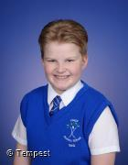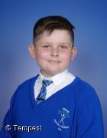



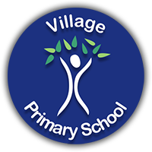

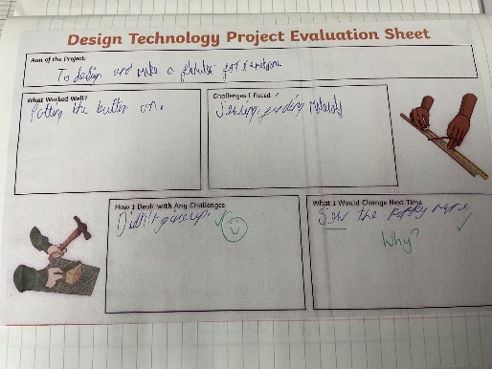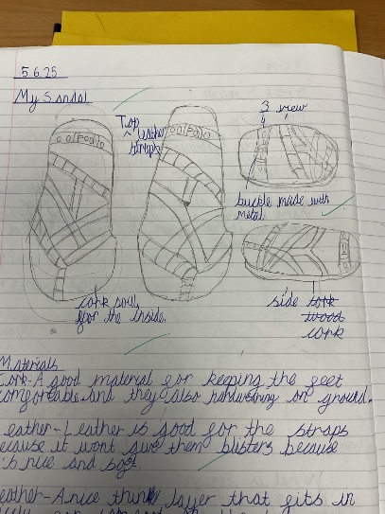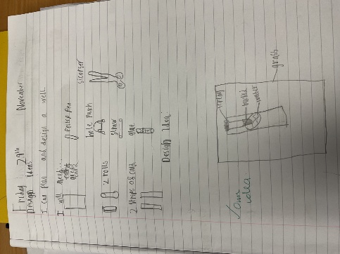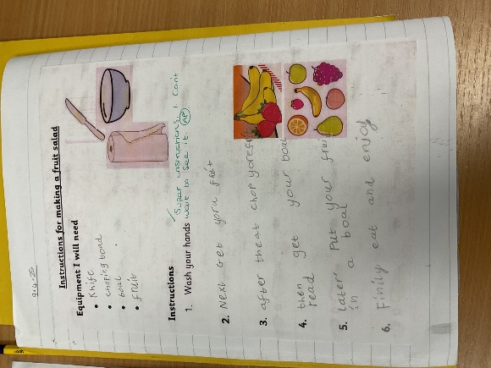**Book Look**

**Strengths:**

* Enthusiasm for the subject
* Ability to recall what has been taught
* Lots of time for collaboration and interaction between the children

**Next steps:**

* More variety in the materials we are allowed to use
* To have a DT week so the children can work on their project every day and have some continuity across the days rather than the weeks