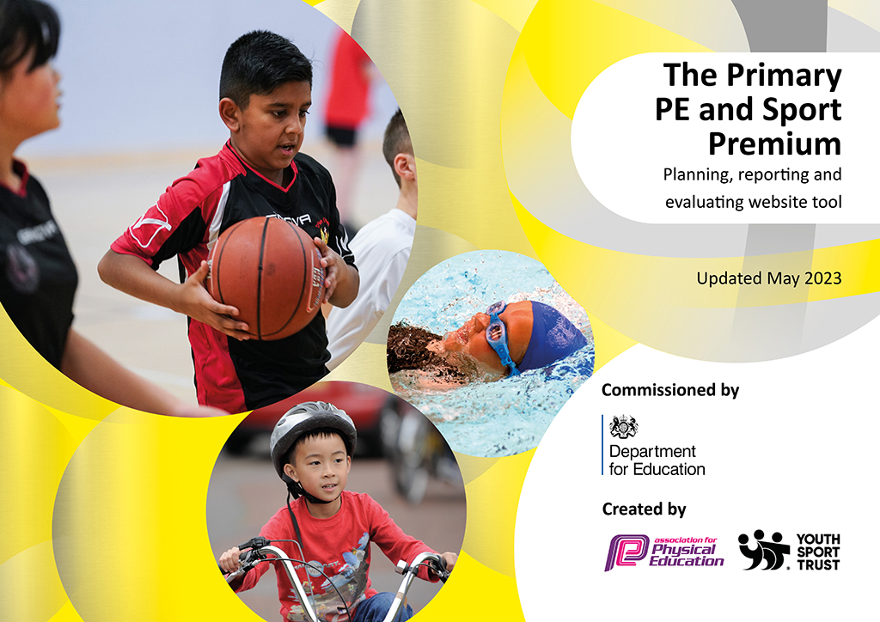
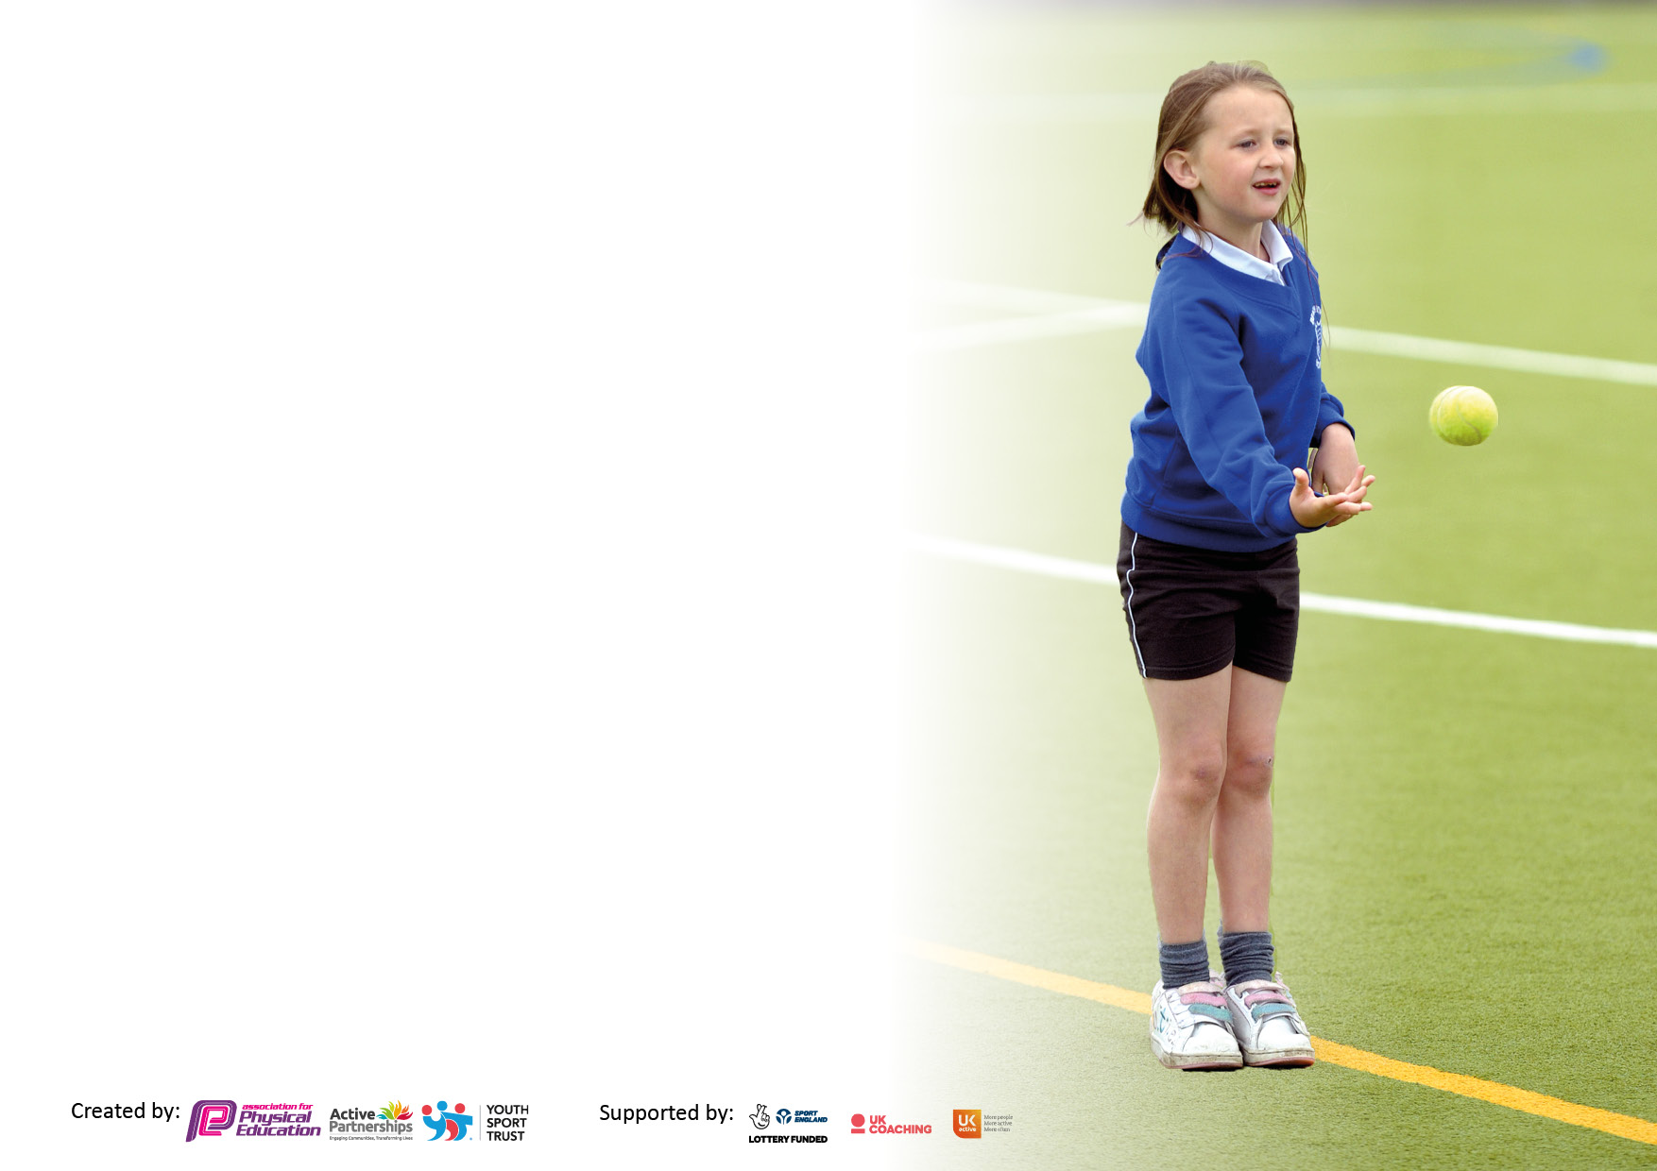

It is important that your grant is used effectively and based on school need. The Education Inspection Framework makes clear there will be a focus on ‘whether leaders and those responsible for governors all understand their respective roles and perform these in a way that enhances the effectiveness of the school’.

Under the Quality of Education Ofsted inspectors consider:
Intent - Curriculum design, coverage and appropriateness
Implementation - Curriculum delivery, Teaching (pedagogy) and Assessment
Impact - Attainment and progress

To assist schools with common transferable language this template has been developed to utilise the same three headings which should make your plans easily transferable between working documents.

Schools must use the funding to make additional and sustainable improvements to the quality of Physical Education, School Sport and Physical Activity (PESSPA) they offer. This means that you should use the Primary PE and sport premium to:

- Develop or add to the PESSPA activities that your school already offer
- Build capacity and capability within the school to ensure that improvements made now will benefit pupils joining the school in future years
- The Primary PE and sport premium should not be used to fund capital spend projects; the school’s budget should fund these.

Pleasevisitgov.ukfortherevisedDfEguidanceincludingthe5keyindicatorsacrosswhichschoolsshoulddemonstrate animprovement.Thisdocumentwillhelpyoutoreviewyourprovisionandtoreportyourspend.DfEencouragesschools to use this template as an effective way of meeting the reporting requirements of the Primary PE and Sport Premium.

We recommend you start by reflecting on the impact of current provision and reviewing the previous spend.

Schools are required to publish details of how they spend this funding, including any under-spend from 2021/2022, as well as on the impact it has on pupils’ PE and sport participation and attainment. All funding must be spent by 31st July 2023.

We recommend regularly updating the table and publishing it on your website throughout the year. This evidences your ongoing self-evaluation of how you are using the funding to secure maximum, sustainable impact. Final copy must be posted on your website by the end of the academic year and no later than the 31st July 2023. To see an example of how to complete the table please click HERE.

Details with regard to funding
Please complete the table below.

Total amount carried over from 2021/22 | £0
Total amount allocated for 2021/22 | £17,700
How much (if any) do you intend to carry over from this total fund into 2022/23? | £0
Total amount allocated for 2022/23 | £17,700
Total amount of funding for 2023/24. To be spent and reported on by 31st July 2024. | £ 17,700
Swimming Data
Please report on your Swimming Data below.

Meeting national curriculum requirements for swimming and water safety.

N.B. Complete this section to your best ability. For example you might have practised safe self-rescue techniques on dry land which you can then transfer to the pool when school swimming restarts.
Due to exceptional circumstances priority should be given to ensuring that pupils can perform safe self rescue even if they do not fully meet the first two requirements of the NC programme of study
What percentage of your current Year 6 cohort swim competently, confidently and proficiently over a distance of at least 25 metres?  N.B. Even though your pupils may swim in another year please report on their attainment on leaving primary school at the end of the summer term 2022.  Please see note above | 83%
What percentage of your current Year 6 cohort use a range of strokes effectively [for example, front crawl, backstroke and breaststroke]?  Please see note above | 70%
What percentage of your current Year 6 cohort perform safe self-rescue in different water-based situations? | 83%
Schools can choose to use the Primary PE and sport premium to provide additional provision for swimming but this must be for activity over and above the national curriculum requirements. Have you used it in this way? | No

Action Plan and Budget Tracking
Capture your intended annual spend against the 5 key indicators. Clarify the success criteria and evidence of impact that you intend to measure to evaluate for pupils today and for the future.

Academic Year: 2022/23 | Total fund allocated: | Date Updated:
Key indicator 1: The engagement of all pupils in regular physical activity – Chief Medical Officers guidelines recommend that primary school pupils undertake at least 30 minutes of physical activity a day in school |  |  |  | Percentage of total allocation:
 |  |  |  | 66%
Intent | Implementation |  | Impact
Your school focus should be clear what you want the pupils to know and be able to do and about  what they need to learn and to  consolidate through practice: | Make sure your actions to achieve are linked to your intentions: | Funding allocated: | Evidence of impact: what do pupils now know and what can they now do? What has changed?: | Sustainability and suggested next steps:
There is a high level of obesity in Village Primary school; approximately 1 in every 4 children are obese by Y6. Fitness levels have decresed during covid and cost of living crisis is also having a negative effect on fitness levels – many not taking part in after school activities and poor diets. Village Primary School are determined to reduce levels of obesity through daily physical activity.  School believes that there is a direct correlation between physical confidence and academic progress: regular physical activity promotes growth and development and has multiple benefits for physical, mental, and psychosocial health that undoubtedly contribute to learning. Therefore, if children achieve well in physical education this will positively impact on their progress in other subjects. | Hire a PEAK PE TA Apprentice to support PE provision across school.  Liaise with coaches to plan for events and curriculum coverage. 18 month contract – amount divided over 2 academic years.  Sport activities delivered by PEAK TA Apprentice before school during Breakfast Club sessions, during lunchtime and after-school.  Staff use free online resources and created class fitness videos for the IWB to facilitate ‘activity breaks’ during lesson time, wet breaktimes etc Active lessons are planned throughout the curriculum.  Staff and pupil training from SSSP Join the SSSP for competitions, events and training.  After apprenticeship was completed we kept on the sports coach to deliver extra curricular sports during and after school and to train and support staff. | £4730.42  £2114  £6825 | Children across KS2 have all participated in a wide variety of sports games (please see Sports Participation Tracker). Evidence also on school PE page on website and Twitter.  Children’s activity levels have increased; all participate in 60 minutes of daily physical activity in addition to PE lessons.  Increased levels of well-being and less children classed as obese.  All children across included in PE events throughout the school year.  Engage children during Breakfast Club in physical activity to provide an active start to the day. Monday mornings begin with a stamina session for every class in the school. | Children’s physical development increases. Baselines and end points are measured and demonstrate improved physical performance and endurance.  Increased participating in after-school sports sessions prior to covid.  Children’s performance and enthusiasm for sport improves. Increase chances of children competing in sports events and continuing sport development in and outside of school.  Decrease levels of obesity and inactivity by Year 6.
Key indicator 2: The profile of PESSPA being raised across the school as a tool for whole school improvement |  |  |  | Percentage of total allocation:
 |  |  |  | 3%
Intent | Implementation |  | Impact
Your school focus should be clear what you want the pupils to know and be able to do and about  what they need to learn and to  consolidate through practice: | Make sure your actions to achieve are linked to your intentions: | Funding allocated: | Evidence of impact: what do pupils now know and what can they now do? What has changed?: | Sustainability and suggested next steps:
Physical activity is essential for a healthy lifestyle. We want to empower both staff and children to lead school improvement in PE and sport; our vision is that everyone can be outstanding role models and should promote physical activity every day at Village Primary School. Our goal is to ensure that children have the positive mental attitude, confidence, skills and knowledge to maintain a healthy, active lifestyle independently as they leave school and grow into adults.  My personal best scheme of work has been planned for and added to whole school long term plan in order to embed leadership skills across the entire school.  Children attend leadership training in September so that they can lead physical activities during active breaks. | Pupils trained as Sports Leaders to lead games during break and lunchtime. This was done virtually.  Sports attainment and progress tracking system implemented.  Leaders provided with uniform (caps and hoodies) to stand out at playtimes.  Embedded and reviewed each term.  All class teachers teach PE and wear appropriate sports clothing – staff promote fitness and well- being and are models for all children. | £50 | Pupils are engaged in weekly lessons of sports taught by teachers supported by specialist coaches. (PEAK coach and apprentice)  Improved confidence in PE lessons and higher levels of fitness.  Pupils take on an active role in leadership of games and supporting others.  Sports certificates awarded in assembly to high profile PE.  Profile of PE and sport raised across school and to parents via ‘Village Voice’ weekly newsletter and digital images on the school website and social media.  Whole school staff CPD planned and delivered. Following this CPD, pupils are taught high quality PE lessons by staff who have increased knowledge and confidence.  Increased participation in sporting events.  Targeted provision following data analysis to ensure all children make progress in PE. | Children’s performance and enthusiasm for sport improves to increase chances of competing in events and continuing sport development in and outside of school and in later life as they leave Village.  Pupil voice evidences that children at Village have the positive mental attitude, confidence, skills and knowledge to maintain a healthy, active lifestyle independently as they leave school and grow into adults.

Key indicator 3: Increased confidence, knowledge and skills of all staff in teaching PE and sport |  |  |  | Percentage of total allocation:
 |  |  |  | 12%
Intent | Implementation |  | Impact
Your school focus should be clear | Make sure your actions to | Funding | Evidence of impact: what do | Sustainability and suggested
what you want the pupils to know | achieve are linked to your | allocated: | pupils now know and what | next steps:
and be able to do and about | intentions: |  | can they now do? What has
what they need to learn and to |  |  | changed?:
consolidate through practice:
At Village Primary we provide outstanding PE and sport lessons; through rigorous CPD, our teachers are equipped to provide the children with the very best provision. This ensures that children have increased confidence, knowledge and skills in PE and sport. | Hire PEAK qualified sports coaches to work with teachers to provide existing staff with training and resources to help them teach PE and sport more effectively.  PEAK provide CPD for teachers on PE curriculum and physical literacy.  As part of Stockton Sports Partnership, we receive staff CPD which has been used to provide training for all staff. | £2114 | Pupils are engaged and inspired to learn and develop sports skills by coaches working in partnership with teachers.  The scheme of work taught is progressive, engaging and incorporates a range of sports and skills. | Co-delivery of lessons.  Staff to observe different areas of PE and to contribute to schemes of work.  School has sustainable sports provision; upskilled staff who can teach a variety of sports to an improved standard to raise attainment and progress in PE.  Develop further opportunities for CPD focused on a range of areas.  Staff audit to assess their confidence and areas for development to plan targeted CPD.
Key indicator 4: Broader experience of a range of sports and activities offered to all pupils |  |  |  | Percentage of total allocation:
 |  |  |  | 11%
Intent | Implementation |  | Impact
Your school focus should be clear | Make sure your actions to | Funding | Evidence of impact: what do | Sustainability and suggested
what you want the pupils to know | achieve are linked to your | allocated: | pupils now know and what | next steps:
and be able to do and about | intentions: |  | can they now do? What has
what they need to learn and to |  |  | changed?:
consolidate through practice:
Village Primary School is in receipt of 43.5% pupil premium funding: there is a high level of social deprivation in the area and families cannot always afford to fund extra-curricular activities. It is our vision that all children have the opportunity to experience a broad range of sports to pursue physical activities to suit their interests in the future.  After school clubs available this year:  Ballet, boys football, girls football, dance, archery, rounders, rugby, athletics, running club, coding club, gymnastics, chess club. | Hire a PEAK qualified sports coach to lead a range of afterschool cubs and prepare for competitive events. Clubs held after school and during lunchtime.  Offer multi-sports clubs including football, gymnastics, netball, dance, rugby, archery, athletics, running and dance.  Resource Sport Leader provision to increase the range of sports offered to pupils. Sports and games organised every lunchtime. Focus on active breaks.  Outdoor resources purchased/replenished.  Sports coach to work with children afterschool.  Sports leader to be part of academy PE group.  Pe working party group to plan a Trust athletics sports day for Year 5 and 6 children to participate in. | (as above)  £150 to subsidise clubs  £2200  (as above) | Children offered a variety of sports afterschool opportunities to engage in further physical activity.  Develop and extend their interest in sports. Higher level of activity and fitness.  Children are engaged in sports that they may not have considered before. | Children are engaged in sports sessions afterschool to extend opportunities for physical activity and develop an interest in a variety of sports.

Key indicator 5: Increased participation in competitive sport |  |  |  | Percentage of total allocation:
 |  |  |  | 8%
Intent | Implementation |  | Impact
Your school focus should be clear | Make sure your actions to | Funding | Evidence of impact: what do | Sustainability and suggested
what you want the pupils to know | achieve are linked to your | allocated: | pupils now know and what | next steps:
and be able to do and about | intentions: |  | can they now do? What has
what they need to learn and to |  |  | changed?:
consolidate through practice:
Healthy competition promotes a keen interest in personal challenge, reaching and exceeding targets and achieving personal bests. At Village Primary School we endeavour to provide all children with the opportunity to compete in and out of school; to invoke a growth mindset we wish for all children to experience and positively learn from success and failure. It is our vision to positively promote the values of good sportsmanship in competitive sport. | Hire a PEAK qualitied sports coach to prepare children for competition events. This is planned for (see weekly coach timetable)  Stockton Schools Sport Partnership subscription.  A Participation Tracker devised by the PE Leader to monitor and target PE provision.  Transport to sports events.  Courses attended and information disseminate to staff.  PE Leader to monitor and target PE provision.  Pe lead to join working party and plan a Trust athletics competition | (see above)  See above  Free – made by Sports Leader  £1700  Free as part of SSSP | Participation in cluster, Stockton and Tees Valley events in a variety of sports.  Pupils experience celebration of achievement of others and themselves through events attended. Pupil’s activity levels increase.  Pupils learn how to compete against themselves and others. Pupils develop sportsmanship and teamwork.  Increased confidence when participating in competitions.  Children are engaged in competitive sports events to extend opportunities for physical activity and increase interest in sports.  All Year 5 and 6 attended Sports village for a Trust athletics sports day with other schools from the Prince Regent Street Academy. | Provides focus for competitive sports opportunities and increases sports performance and enthusiasm.  Create opportunities to acknowledge achievement in sports performance and in progress.  Pupils use the skills they have developed in PE and at competitive sports events in other contexts in and out of school, to deal with challenging situations maturely.  Children attend sports events to participate in competitive opportunities.  Have another Trust athletics sports day – look at inviting more children next year – possibility for Year 4, 5 and 6.

Signed off by
Head Teacher: | R.Birtwistle
Date: | 17.7.23
Subject Leader: | Nicola Nixon
Date: | 14.7.23
Governor: | R.Wright
Date: | 17.7.23

